Instructions for The Completion of Standing Order Mandate Form

Please fill in:
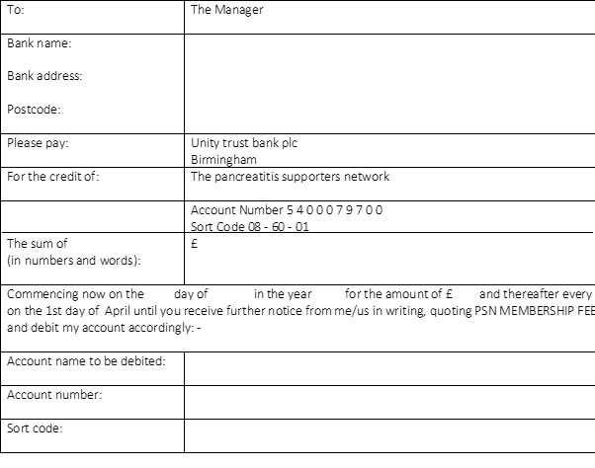

Your bank’s name and

address

Your membership fee (either £7.50 0r £10 in figures and words)

Date the form

Your account name

Your account number

Sort code

Sign and date the form where it says signature/date

Please print out and complete, and return the whole form to your personal bank to undertake the instructions.

There is enough information herein for you to set payment up online as well

NB: with standing orders I/we cannot request any money from your account and you can stop this at any time by writing to your bank

STANDING ORDER MANDATE

To: | The Manager
Bank name:

Bank address:

Postcode:

Please pay: | Unity trust bank plc  Birmingham
For the credit of: | The pancreatitis supporters network

Account Number 5 4 0 0 0 7 9 7 0 0

Sort Code 08 - 60 - 01
The sum of  (in numbers and words): | £
Commencing now on the day of in the year for the amount of £ and thereafter every year on the 1st day of April until you receive further notice from me/us in writing, quoting PSN MEMBERSHIP FEE and debit my account accordingly: -

Account name to be debited:

Account number:

Sort code:

Signature: ____________________________________

Date: _____________________________________

This Standing Order Mandate supersedes all previous standing orders to The Pancreatitis Supporters Network

The Bank will not undertake to :
- make any reference to Value Added Tax or other indeterminate element.
- advise payer’s address to beneficiary.
- advise beneficiary of inability to pay.
- request beneficiary’s banker to advise beneficiary or receipt.

